CI/CD Pipeline: Building and Pushing Docker Images from GitHub to Docker Hub Using GitHub Actions

Prerequisites
Before starting, make sure you have:
- A GitHub account
- A Docker Hub account
- Docker installed locally (for testing)
- Your project hosted on GitHub (e.g., a simple Spring Boot App with a Dockerfile)

Step 1: Create a “Dockerfile” in Your Project

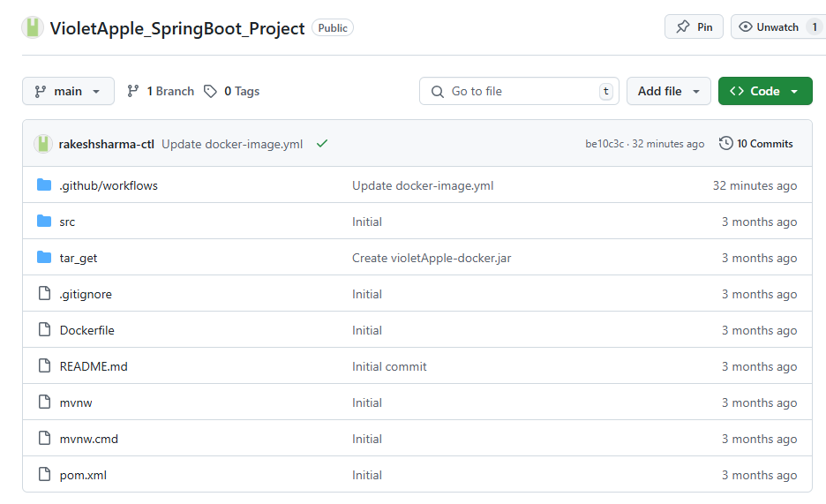

1. # 1️Use an official Java runtime as the base image
2. FROM openjdk:17-jdk-slim
3.
4. # 2️Set the working directory inside the container
5. WORKDIR /app
6.
7. # 3️Copy the built JAR file into the container
8. COPY target/violetApple-docker.jar app.jar
9.
10. # 4️Expose the application port
11. EXPOSE 8080
12.
13. # 5️Run the application
14. ENTRYPOINT ["java", "-jar", "app.jar"]

Step 2: Create a Repository on GitHub
If you haven’t already:
- Push your local project to GitHub
- Make sure the Dockerfile is in the root or specified directory

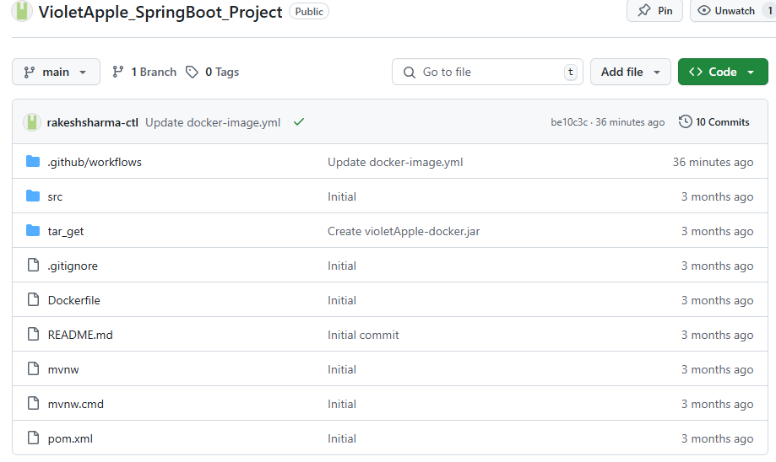
A typical GitHub repository root view

Step 3: Store Docker Hub Credentials as GitHub Secrets
Go to your GitHub repo → Settings → Secrets and variables → Actions → New repository secret

Add these secrets:

Name | Value
DOCKER_HUB_TOKEN | Your Docker Hub username

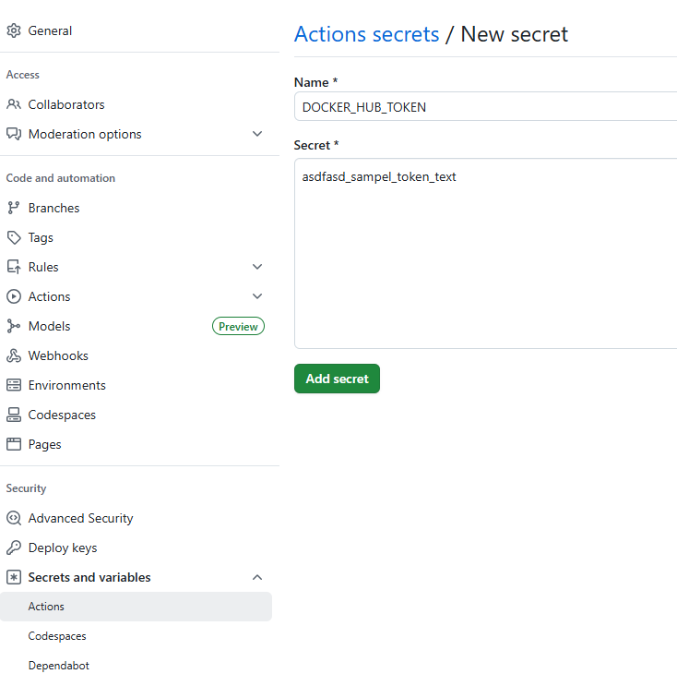
Step 4: Create GitHub Actions Workflow
In your repo, create this file:

1. .github/workflows/docker-image.yml

Sample “docker-image.yml” for a SpringBoot Application

1. name: Docker Image CI
2.
Action workflow gets executed when push or pull request is initiated in “main” branch.
3. on:
4. push:
5. branches: [ "main" ]
6. pull_request:
7. branches: [ "main" ]
8.
We have used ubuntu latest version as operating system.
9. jobs:
10. build-and-push:
11. runs-on: ubuntu-latest
12.
13. steps:
14. - name: Checkout Code
15. uses: actions/checkout@v4
16.
17. - name: Set up JDK 17
18. uses: actions/setup-java@v3
19. with:
20. java-version: '17'
21. distribution: 'temurin'
22.
23. - name: Build with Maven
24. run: mvn clean package -DskipTests
25.
26. - name: Log in to Docker Hub using CLI
27. run: docker login -u sharmarakesh -p ${{ secrets.DOCKER_HUB_TOKEN }}
Docker token stored in Action secrets
28.
Github username
29. - name: Build Docker Image
30. run: |
31. docker build -t sharmarakesh/violetapple-springboot-project:latest .
32.
33. - name: Push Docker Image to Docker Hub
Name image always as latest.
34. run: |
35. docker push sharmarakesh/violetapple-springboot-project:latest

Step 5: Commit and Push the Workflow
Once the workflow YAML is committed and pushed to the main branch, it will automatically trigger the pipeline.

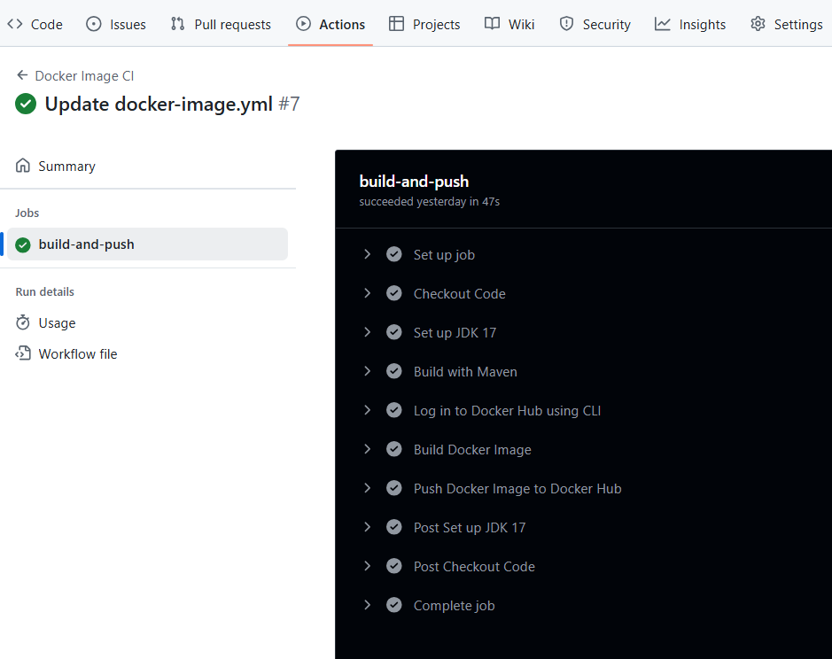

Step 6: Confirm on Docker Hub
Go to Docker Hub → Check your repository → The latest image should be pushed.

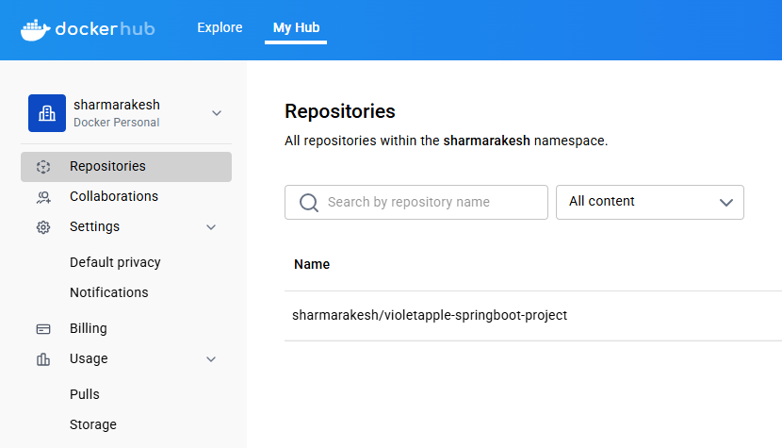
Latest image shown here

Step 6: Test on Docker Desktop
- Once the image is pushed to Docker Hub, you can test it locally using Docker Desktop.
- Pull the image from Docker Hub.
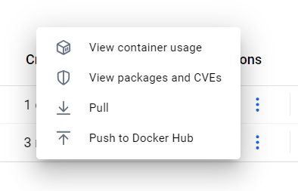
Click on the three dots to get Pull option.
- Run a container from the image.

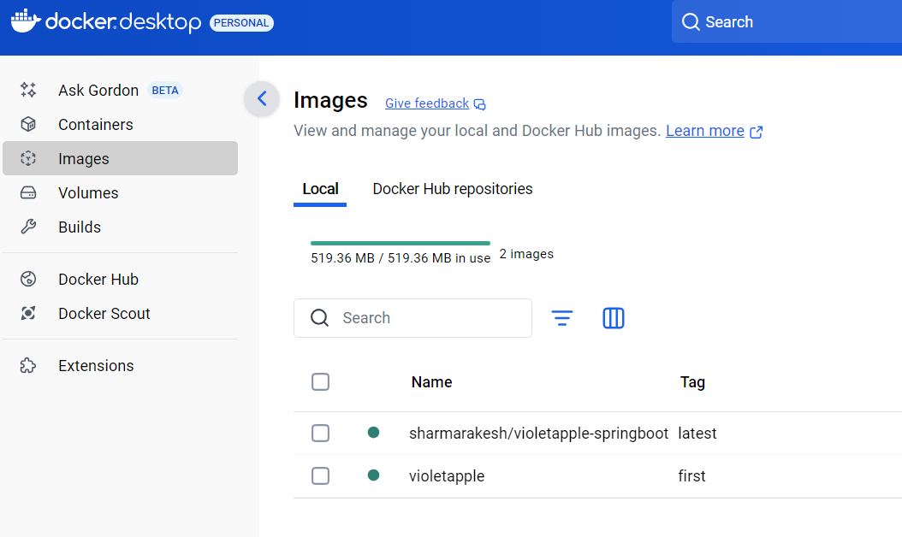

- Open Docker Desktop to confirm the container is running.
- Visit http://localhost:8080 (or your chosen port) in a browser to test the application.

